
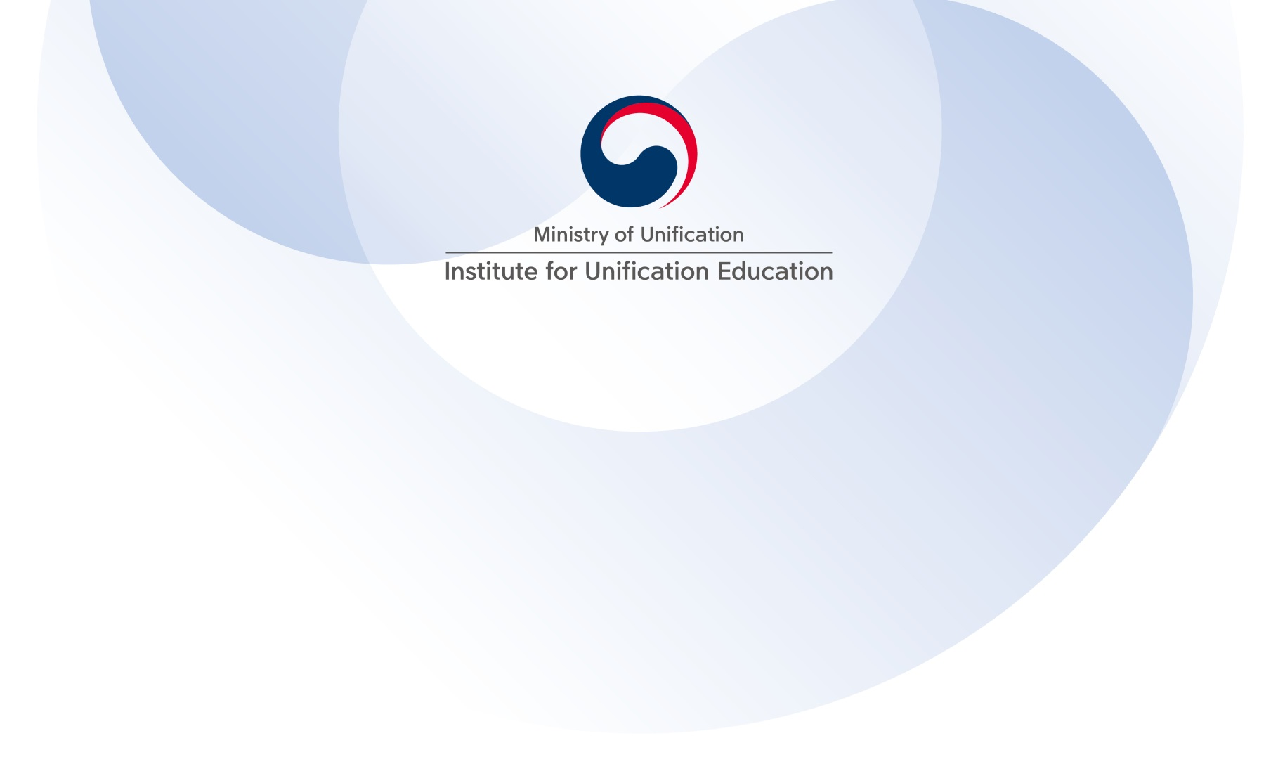
123, 4.19-ro (Suyu-dong), Gangbuk-gu, Seoul 01018
2017 Junior Korean Unification Experts Fellowship

- Fellowship Overview
The Institute for Unification Education of the Ministry of Unification of the Republic of Korea provides “The Junior Korean Unification Experts Fellowship (JKUEF)” for mid-career foreign experts and scholars who are interested in Korean affairs. This fellowship, since its launch five years ago, has played a meaningful role for international scholars and practitioners to deepen their knowledge of issues concerning the Korean peninsula. If you want to join JKUEF, please read more below.

- Objectives of Fellowship
- To promote a global understanding of the ROK government’s policy towards North Korea and a vision for Korean unification.
- To build network among experts and scholars of Korea and foreign countries that will serve as a critical asset for international cooperation for Korean unification.

- Outlines of Fellowship
- Period: July 3rd ~ 12th (ten days)
- Number of participants: Approximately twenty
- Program: Participant will join lectures, free discussion on the chosen subjects, field trips and a full-day academic seminar. Examples are below.
Lecture Subjects | - ROK’s unification policy and vision for Korean unification  - ROK’s unification diplomacy and international cooperation  - Security issues surrounding the Korean peninsula  - Understanding of North Korea
Field Trips | - DMZ and Panmunjeom  - Inter-Korean Transit Office  - High School for North Korean Refugees (Hanawon)  - Cultural Heritage Sites  - Government agencies or research institutes
Academic Seminar | -All participants will join Academic Seminar (either as presenters or discussants) to discuss with Korean counterparts.

123, 4.19-ro (Suyu-dong), Gangbuk-gu, Seoul 01018

- Eligibility
The applicant must meet one of the following criteria.
- Mid-career employees working at governments, international organizations, or non-government organizations in relevant areas, preferably with a M.A or higher degrees.
- Junior scholars or researchers at universities, institutes, or think tanks in relevant areas, preferably with a Ph.D.
*Applicants need to have competent level of English language ability since the program’s working language is English.

- Required Documents and Application Procedures
All of the following application documents should be submitted to unik528@korea.kr or unik528@unikorea.go.kr
- Application Form / Personal Statement
Please fill out the form with necessary information with a photo attached. (Attachment)
- Curriculum Vitae
- Letter of Reference
The applicant is requested to submit one letter of reference. The reference should come from individuals who have supervised him/her in a professional capacity. The reference writer should comment on this fellowship’s suitability for the applicant’s professional or academic career as well as his/her goals and strengths.
- Application Deadline
April 2(Sun), 2017
- Result Notification
The result will be notified individually at the end of April
*Subsequent notice email will be sent after the result is notified to guide the selected participants through preparation for JKUEF, including air ticket purchase, hotel info, presentation/discussion paper writing, etc.

123, 4.19-ro (Suyu-dong), Gangbuk-gu, Seoul 01018

- Terms and Conditions
(1) The IUE covers the following expenses
- Round trip international airfare (Economy Class)
* The participant will purchase the air ticket, and then get reimbursed in US dollars (cash) based on the receipt submitted to the IUE near the start of the fellowship.
* Costs in excess of the IUE internal airfare guideline will be paid at one’s own expenses. The detailed guideline differentiated by country will be informed later in the process of preparation for participation.
- Accommodation during the fellowship
*Stays before and after the fellowship will be paid at one’s own expenses.
- Meals (breakfast and lunch) during the fellowship
- Admission fees for scheduled field trips
- Transportation
- Travel insurance
- Honorarium for presentation and discussion at the Academic Seminar
* Participants are expected to cover personal expenses, i.e., visa fees, excess baggage charge, travel expenses between airport and accommodation, charge for items or services other than complimentarily given at accommodation in Korea.

< Attachment 1> Application Form
<Attachment 2> Personal Statement

<Attachment 1 - Application Form>

123, 4.19-ro (Suyu-dong), Gangbuk-gu, Seoul 01018
Application for 2017 Junior Korean Unification Experts Fellowship

- Personal Information
Name in Full | Family Name (surname) First and middle name |  |  | (Photo)
Nationality
Occupation
Gender
Date of Birth
Country of Birth
Contact | Mailing Address | Home
Contact | Mailing Address | Office
Contact | Phone No. | Home
Contact | Phone No. | Office
Contact | Email
Present Position | Employer
Present Position | Department |  | Title

- Education *Fill out in the reverse chronological order.
Name and country of educational establishments | Years attended | Degrees | Major | Date obtained
 | ~
 | ~
 | ~
 | ~
 | ~

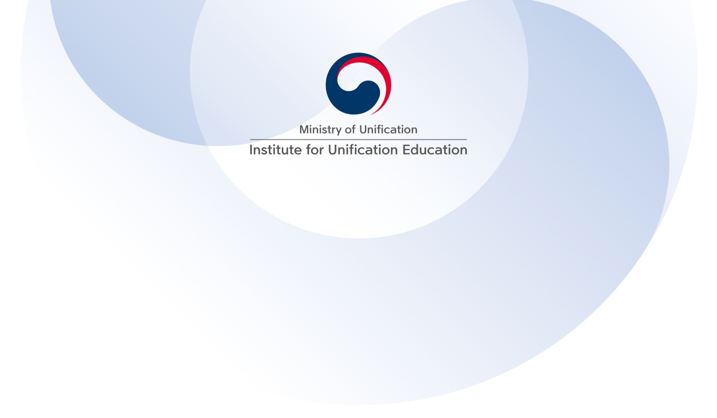

123, 4.19-ro (Suyu-dong), Gangbuk-gu, Seoul 01018

- Career History *Fill out in the reverse chronological order.
Employer | Title | Working Period | Responsibilities
 |  | ~
 |  | ~
 |  | ~
 |  | ~
 |  | ~

- Publications and research *List any significant publications, including publisher and date of publication and any major research projects undertaken.

- If you have visited or lived in Korea, please fill out below.
Period | Place | Purpose
~
~
~

123, 4.19-ro (Suyu-dong), Gangbuk-gu, Seoul 01018

- Language Proficiency
English | Speak | □ Native □ Excellent □ Good □ Fair □ Poor
English | Read | □ Native □ Excellent □ Good □ Fair □ Poor
English | Write | □ Native □ Excellent □ Good □ Fair □ Poor
Korean | Speak | □ Native □ Excellent □ Good □ Fair □ Poor
Korean | Read | □ Native □ Excellent □ Good □ Fair □ Poor
Korean | Write | □ Native □ Excellent □ Good □ Fair □ Poor

- Where did you find information on the JKUEF? Please specify.

<Attachment 2 – Personal Statement>

123, 4.19-ro (Suyu-dong), Gangbuk-gu, Seoul 01018
Personal Statement
Please write an overview of your academic and professional background and motivation behind why you apply for this fellowship.

